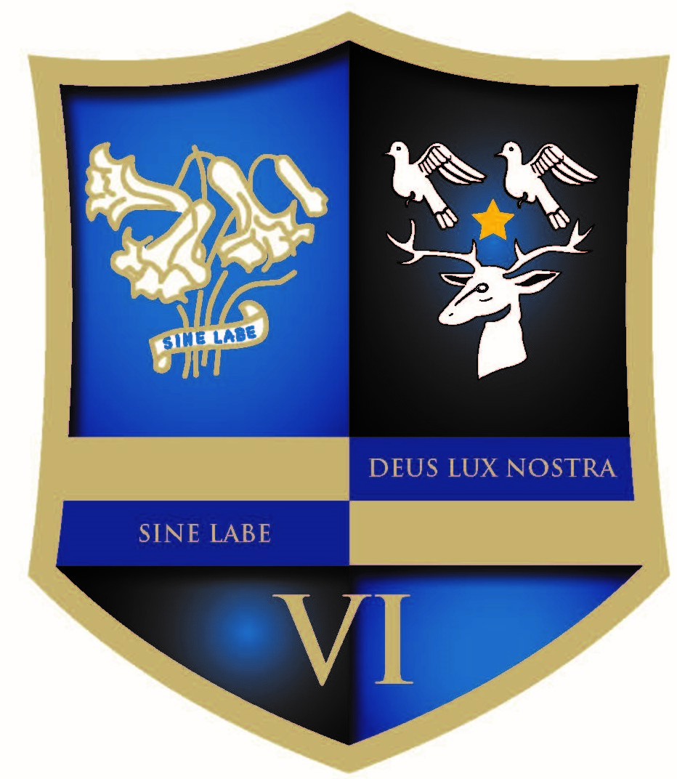

Sixth Form Information Evening – calling all Y11 students!

An Information Evening for prospective entrants to St. Anthony’s and St. Aidan’s Catholic Sixth Form, and their parents, will be held at St. Anthony’s on Monday 8th October 2018 from 6-7pm.

